1. Emotions are quite physical, as different body parts react to different emotions
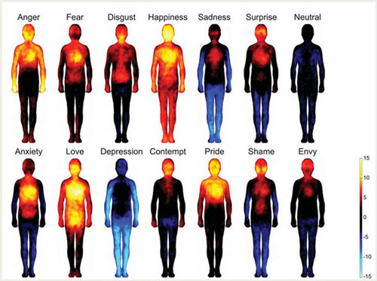
Image source
Fact Source
2. According to scientists, there are 8 primary innate emotions: joy, acceptance, fear, surprise, sadness, disgust, anger, and anticipation
Image source
Other important emotions like ‘love’ are results of permutation and combination of these
Fact Source

3. Laughter is contagious FOR REAL, as your brain prepares your facial muscles for it upon hearing someone else laughing
Image source
Fact Source
5. In fact, your facial muscles kind of control your power of displaying and detecting emotions
Image source
Fact Source
6. Fear makes us actively use more muscles than we usually do
Image source
As it prepares our body for anything bad that might come.
Fact Source
7. And you can actually smell fear, scientists say
Image source
A chemical pheromone is released in their sweat when people are afraid, and other people can smell, even if they are unaware of it.
Fact Source
8. Dreaming helps to diminish the effects of bad memories
Image source
Our brain does it by simply making more logical conclusions of those memories, while we are sleeping, and, therefore, can’t use our judgement.
Fact Source
9. Anger can make people physically sick
Image source
Anger increases the long-term risk of heart attacks and strokes and weakens the immunity system.
Fact Source
10. Smells have quite an effect on our emotions
Image source
Especially unpleasant smells trigger the negative emotions immediately.
Fact Source

11. And that flutter of butterflies in your tummy is actually your stomach crying for help
Image source
Because all the blood is rushing to the muscles and stomach isn’t getting enough supply.
Fact Source
Your emotions are the slaves to your thoughts, and you are the slave to your emotions. ― Elizabeth Gilbert.

